

cd \pascal\supports\react_supports\react_native_projets\RN1

yarn android

Table des matières
1.1 DatePicker 3
1.1.1 Objectif 3
1.1.2 Syntaxes 5
1.1.3 Code 6

DatePicker

Objectif

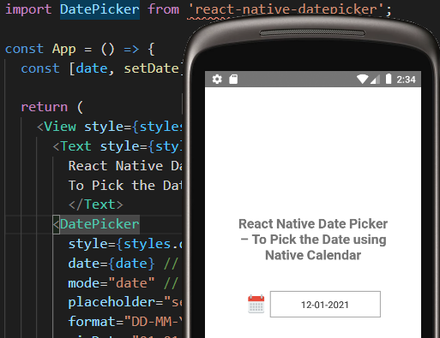

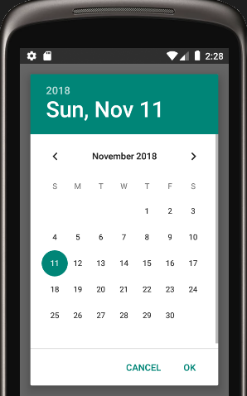

Syntaxes

yarn add react-native-datepicker

Code

/*
DatePickerV1.tsx => App.tsx
*/
// React Native Date Picker – To Pick the Date using Native Calendar
// https://aboutreact.com/react-native-datepicker/

import React, { useState } from 'react';
import { StyleSheet, Text, View } from 'react-native';

//import DatePicker from the package we installed
// npm install react-native-datepicker --save
// MAIS Cannot read property 'match' of undefined
// Plutôt
// yarn add react-native-datepicker

import DatePicker from 'react-native-datepicker';

const App = () => {
const [date, setDate] = useState(new Date());

return (
<View style={styles.container}>
<Text style={styles.title}>
React Native Date Picker –
To Pick the Date using Native Calendar
</Text>
<DatePicker
style={styles.datePickerStyle}
date={date} // Initial date from state
mode="date" // The enum of date, datetime and time
placeholder="select date"
format="DD-MM-YYYY"
minDate="01-01-1900"
maxDate="31-12-2021"
confirmBtnText="Confirm"
cancelBtnText="Cancel"
customStyles={{
dateIcon: {
//display: 'none',
position: 'absolute',
left: 0,
top: 4,
marginLeft: 0,
},
dateInput: {
marginLeft: 36,
},
}}
onDateChange={(date) => {
setDate(date);
}}
/>
</View>
);
};

const styles = StyleSheet.create({
container: {
flex: 1,
padding: 10,
justifyContent: 'center',
alignItems: 'center',
},
title: {
textAlign: 'center',
fontSize: 20,
fontWeight: 'bold',
padding: 20,
},
datePickerStyle: {
width: 200,
marginTop: 20,
},
});

export default App;

